- Super Admin Dashboard – How this revenue is appearing her? As you can see the below circled image is just showing to 200 in total. Use proper names- what does Main branch signifies? I think Admin means Gym owners here? What is Main Branch here? Branch Leader board pls describe /// Super Admin Dash board should show monthly annual revenue/ leads added converted etc

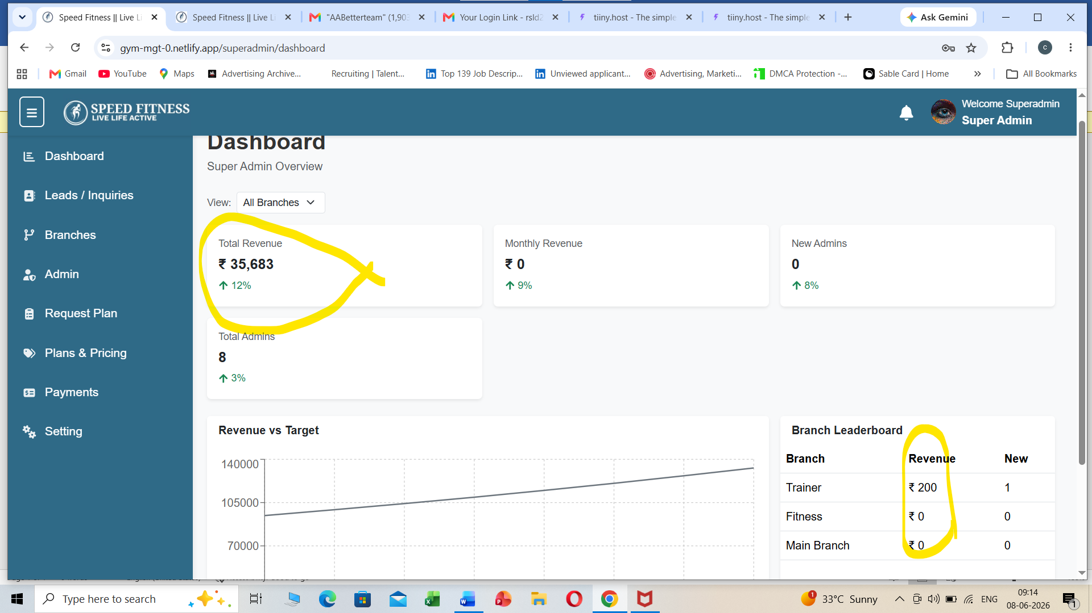

- How this lead came here? I need lead managent here for my super admin Sales person who can add leads here…suppose there are three sales person then they can add leads separately here and there will one total leads section where super admin can seen their leads and total leads. Note- admin of super admin will have give rights to access to sales people who can see which section---/// the reason of total leads here- Wtsp marketing campaign message will be sent to these leads here from wtsp business api// while adding leads its source should lso to be filled for eg- google ads leads or Insta leads etc by drop down

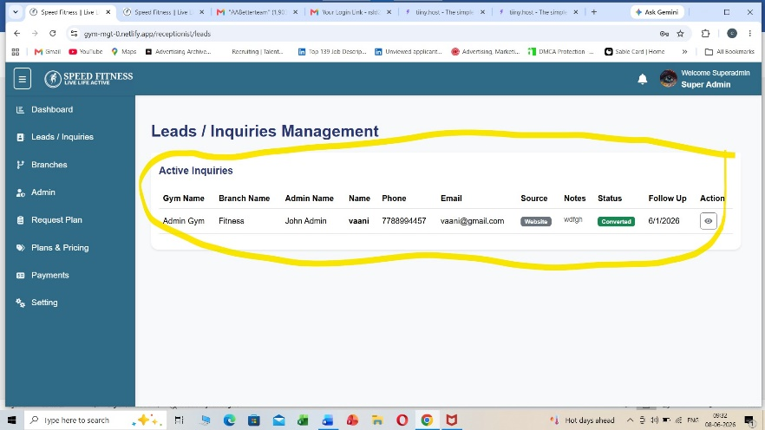

- What is Branch in Super Admin?
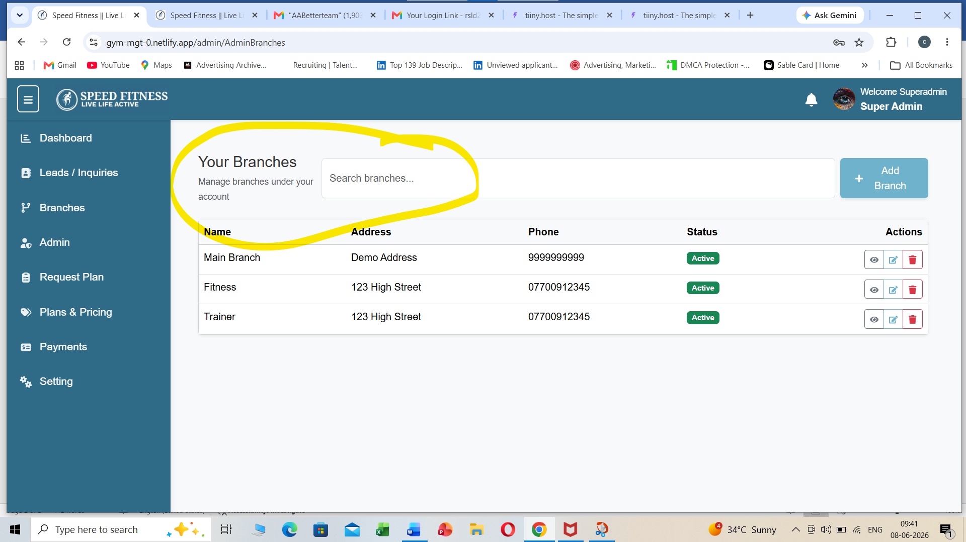

- Add new Admin in Super Admin- This information can be filled by super Admin as well as sales person of Super Admin and Gym owner themselves in their login page.

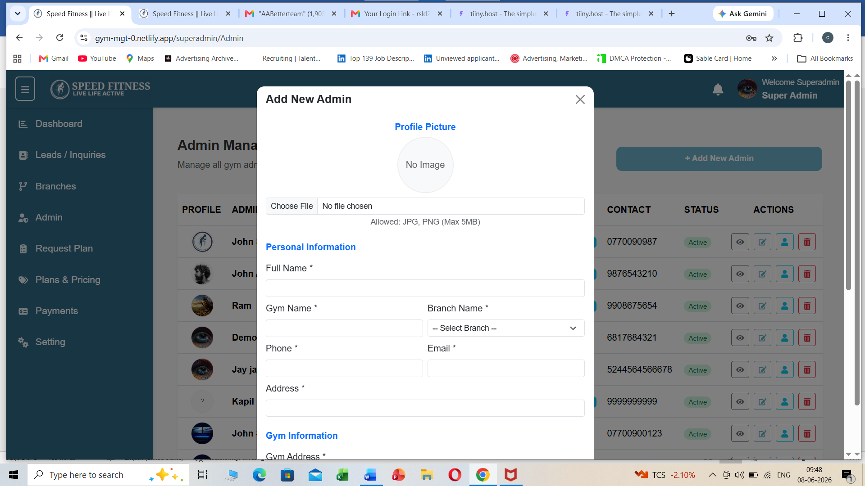
- Request plan in Super Admin- I forgot what I did as test it appeared here… I just approved but it is still not showing in my Admin list/// tell me this complete procedure
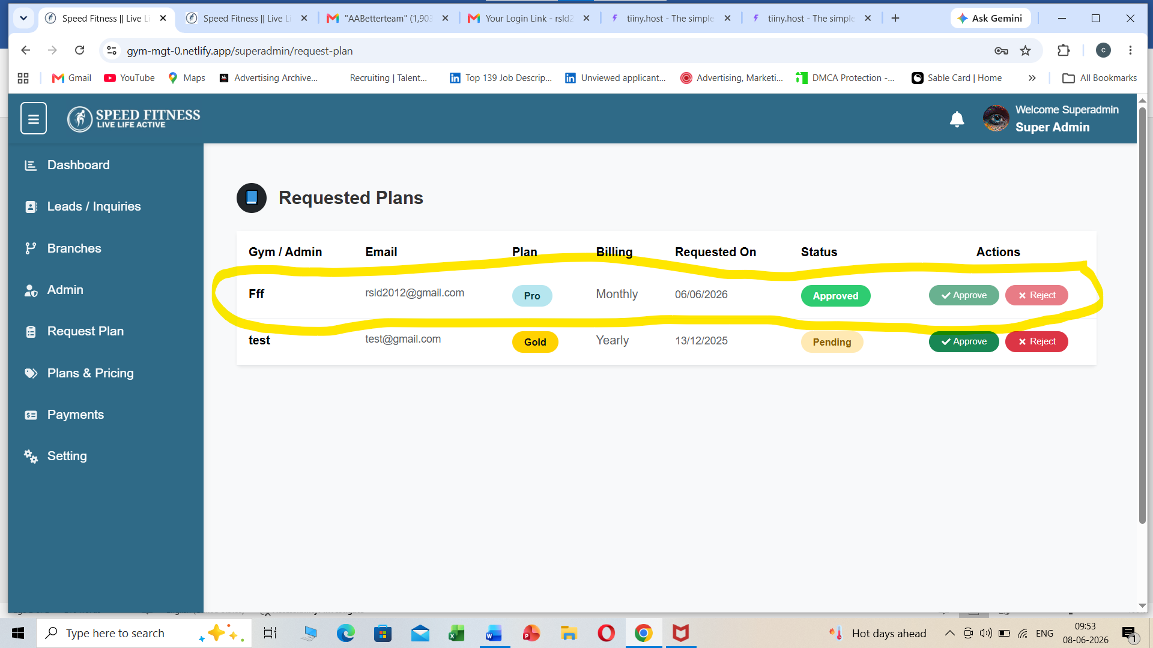

- Payments Super Admin- Please let me know the steps how it appeared here.// Note- suppose any gym owner have not paid monthly fee then there service will automatically be inactive after 3 Days.// so the gym owner will automatically be reciving payment reminder and service inactive wtsp messageges and mails to pay else service inactive like that// Also in main SuperAdmin dashboard it clearly shows upcoming renewals in 7 days and Inactive due to renewals – so that we also have an idea/// we could see whole list which expired and upcoming renewal in 7 days so that we can plan accordingly // Note – everywhere I need export csv options to download in excel or PDF

